Good evening, esteemed members of the Zanskar group. Today is the first day of trading in the stock market this week. Hope it's going great for everyone
Yesterday, I explained the basic patterns of candlestick charts and left you an assignment. I will explain how to judge buying and selling through candlestick patterns. Candlestick charts are indeed essential. When you can not simply through a candlestick to reach a conclusion, you need to base your judgment on this in conjunction with the overall pattern to make a judgment, which is the most useful.
Let's continue from where we left off last night

The more common buy candlestick signals: Firstly, the hammerhead line (hammer line)
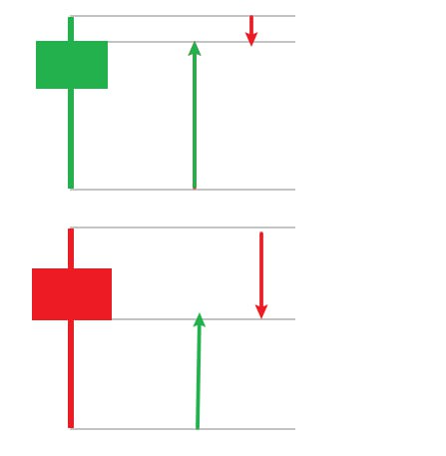
1. We should remember that such a pattern must be at the end of the decline in the market, the appearance of the hammer line before the stock price to go through a period of decline, at this time the emergence of the pattern to have significance
2. The body line entity is very small, generally no upper shadow, even if there is, the upper shadow is also very short can not be too long, but the lower shadow is very long must be more than 2 times the entity, this is a bottoming out reversal signals, the smaller the hammerhead entity, the longer the lower lead, the more obvious the role of the fall, the greater the value of the reference!
3. After the hammerhead line, if the next candlestick is a longer rising candlestick and the closing price exceeds the maximum price of the hammerhead line, then it signals a new round of upward movement, representing a reversal of the market from here on out.
4. After the appearance of the hammerhead line, if the next candlestick is a candlestick with a big drop, the downtrend of the market is likely to be maintained
5. If there is a hammerhead line at the same time, there are other watch patterns (such as the star), the bottom signal is more reliable!
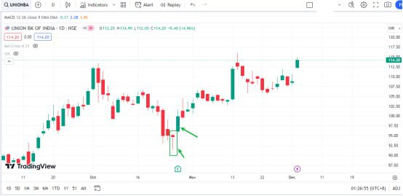
In UNIONBANK you can see that on the 26th of October hammer candlestick appeared at the bottom of the price of the decline in the market, the price of the second day more than the highest price of the hammer line, is a very important signal of reversal, the length of the lower lead can be illustrated by the strength of the bulls at the bottom of the market and the strength of the rebound in the future!
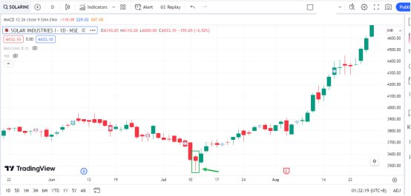
We look at the SOLARINDS, July 11th hammer line the next day the market price is more than the highest price the turning point of the market once again whether it is short or long there will always be weakened one day we know through the knowledge of the previous study the emergence of the hammer line on behalf of the day of the long far over the short, the next day the price breakthroughs before the candlestick highs on behalf of the bulls began to occupy the market dominance and this time it is often the bottom of the generation!
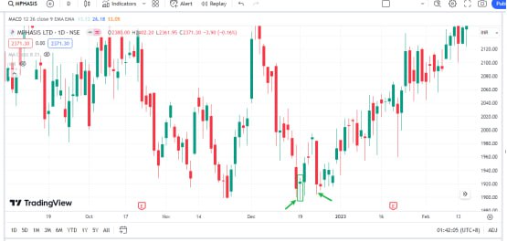
Candlestick patterns, in addition to determining whether the market will turn, signal that there is strong support. The principle is that at the bottom of the market, in the long rapid accumulation of a larger volume of long chips, a long lead often needs more volume to complete, so the point will have a stronger nature of support. Let's look at the MPHASIS market, 22 years after the appearance of the hammer line on 19 December, the late market, although there was a sharp decline, but still did not fall below the hammer line, so in the use of the hammer pattern to buy, we should firmly hold, do not easily washed out by the short side unless it fell below the hammer line!
Second, bullish Engulfing Pattern
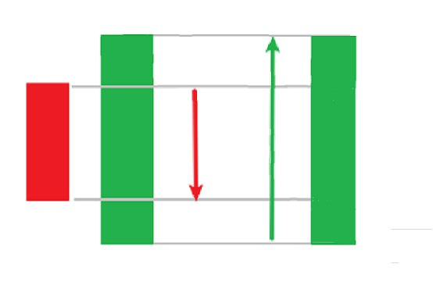
1. Appeared at the bottom of the down market, after a period of decline, when the emergence of the pattern has significance

2. The rising candlestick completely covered the previous day's down candlestick. You can compare the two days of the strength of the short and long, the more obvious the advantage, the more obvious the role of stopping the fall, the greater the value of the reference.
3. After the emergence of the engulfing pattern, the next candlestick is an important reference point. The closing price of the day can not be lower than half of the engulfing candlestick; more than half, in line with the pattern, represents the market from here to start the flip!

4. After an engulfing pattern occurs, the next candlestick is a candlestick with a big drop, and the closing price of the day is less than half of the engulfing rising candlestick, then the downtrend of the market is likely to be maintained.
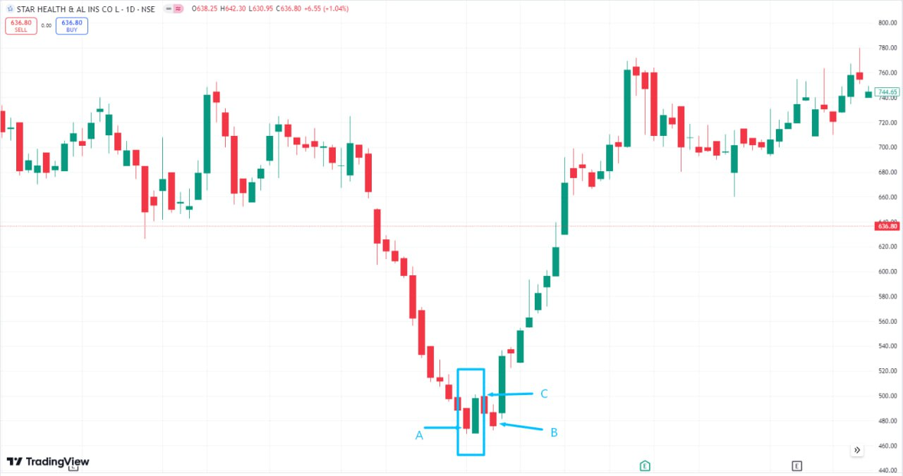
In STARHEALTH, the first down marker in the engulfing pattern, the next day the market continued to fall and did not fall below the engulfing pattern of the closing price of more than half of the day in line with the pattern, it is important to note here that the next day to fall back to the price, although it did not fall below the engulfing pattern of the half, almost similar, at this time it should be more robust for observation, the second day
The market continues to fall but has not fallen below the pattern low, indicating that the previous support is valid; we continue to observe. The real buy point appeared in C, the price breakthrough engulfing pattern, so we can not be archaic in the trading process to remember the form, but keep in mind the form behind the theory of long and short, we observe the engulfing pattern, the rising line covering the falling line, the principle that we can understand the short and long in two days of the game, and the long side to the engulfing trend to take over the short, the formation of an effective uptrend!
After the formation of the engulfing pattern, the point also has strong support. After the fight between the short and the long, often short's inability to fight back against the long often appears as effective support. We can see that in the ITC ltd market, January 4, after the emergence of the engulfing pattern of the market did not fall below the previous lows, even in the February 1 rapid decline in support is still strong, can be used as a reference point for the price of the long side of the concentration of chips, the price of the position can be more determined to hold! This stock has been shared before, because there is a representative here in the repeat!
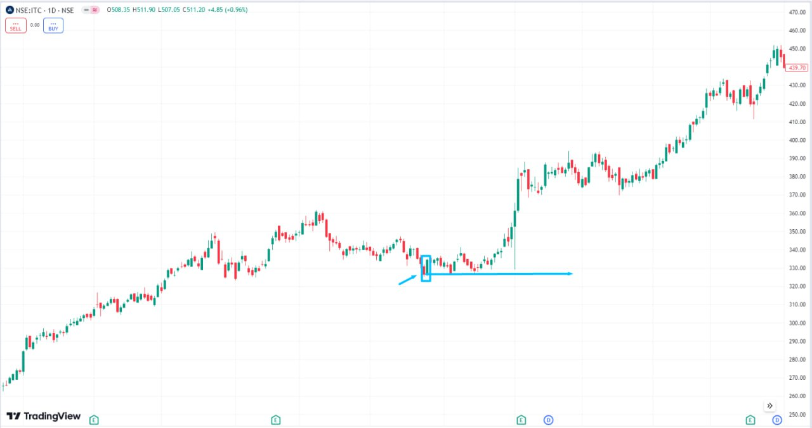
Look at a more special case of the engulfing pattern BDL, we first think about a question, this is not an engulfing pattern? After the appearance of the pattern, the lowest price of the day is not the lowest level of the stage market? Why would it go that way?
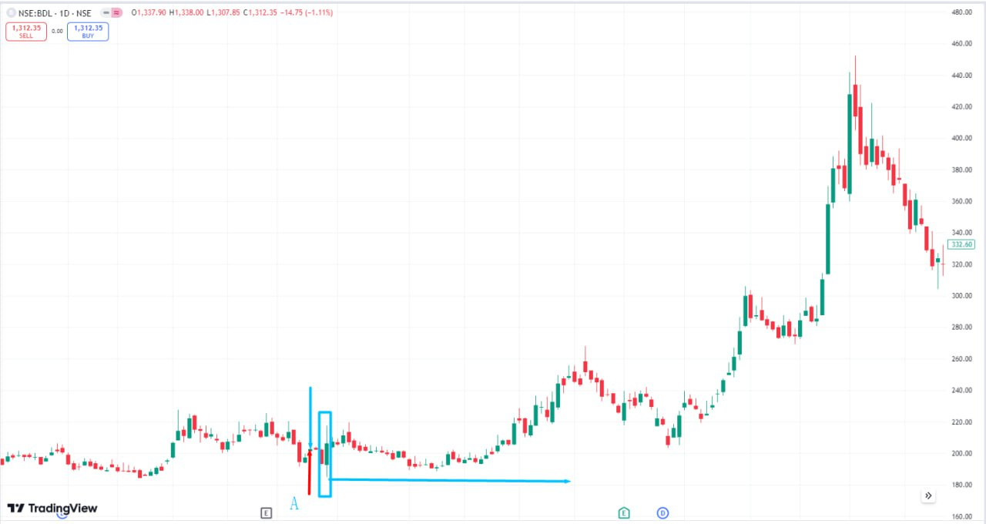
First of all, this is a non-standard engulfing pattern, the downtrend is not obvious, and secondly, back to the principle of the form of analysis, the day of the engulfing pattern, candlesticks appear longer on the lead, on behalf of both sides of the strong strength, but still dominant, we can go to look at the 21 November 30th they are also engulfing the pattern of the emergence of the next day, there is still a long lead, is not on behalf of both short and long is still! in the fight? So this is the engulfing pattern that appeared after a wave of decline, but the decline did not fall below the form of the low point, the market into the finishing before starting to pull up, the reason!
Third, the Star of Enlightenment.
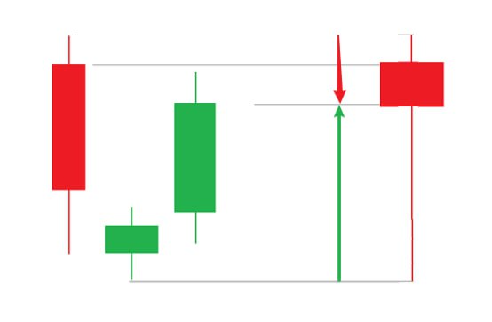
1. There are three candlesticks consisting of the first day in the process of falling on the first day of a large negative line

2. The next day can be a small solid candlestick or a doji, both up and down.

3. The third day up candlestick rises inside the first day's candlestick

4. Here I have made candlestick combinations for you, the star is actually a distortion of the hammer line

5. We judge the strength of the Kairos by comparing the long and short relationships
As a result of the three candlesticks combined, the volume will usually be larger than the hammer and engulfing form, so the reliability is also stronger, but also psychologically constitutes a complete transformation process, bearish psychology, the balance of short and long, looking at the psychological transformation, when the long side is clearly dominant, it is a very good signal to buy!
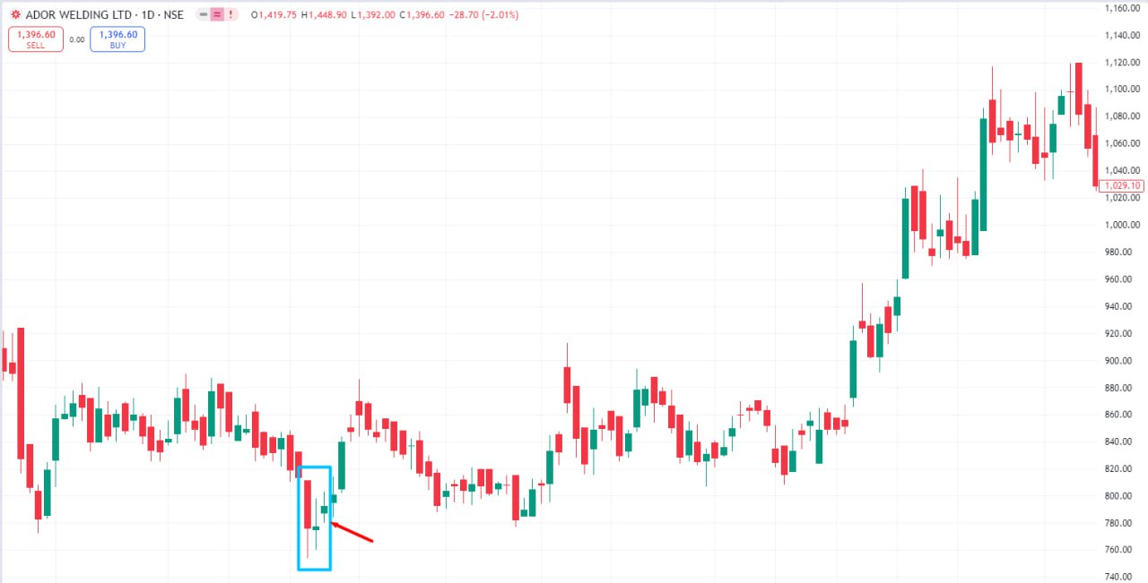
After the appearance of the star, the point of support is stronger than the above two forms, but must pay close attention to the later stage of the ratio of the power of the long and short sides, in the AARVEEDEN 23 March 29 market, the star pattern appeared (Figure A), the next day appeared to rise, but on the third day of the two sides of the long and short sides once again launched a fierce struggle, the market back to the support level to adjust, the long side of the suction before the beginning of stretching. As can be seen from disc B, this fierce game of special positive line, in the later retracement process, played an important support role!
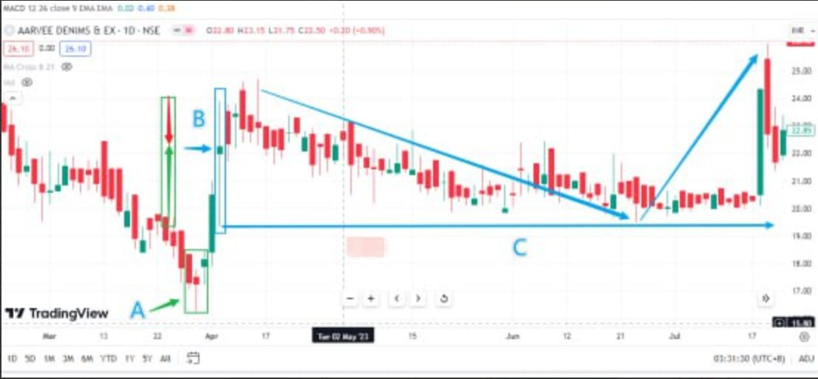
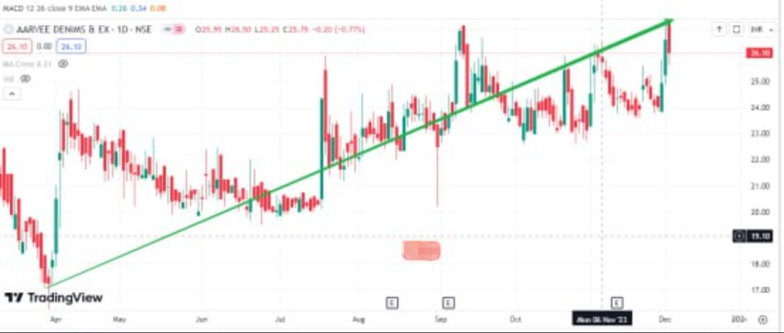
NOTE: The star line candlestick pattern is increasingly popular. Remember the nine Points I will mention. If you can't recall, just keep in mind that the long-short relationship can be important.
1. Look at the location of the star pattern, the pattern occurs in the high, the price has seen a large increase, and the market may be just a wave of small upward market wave, belonging to the banker's shipping market, investors should be timely high of the market. If the pattern occurs at the low, the stock price falls more, maybe the real bottom signal, investors can be a low intermediary.
2. If the lower shadow of the star-shaped pattern is longer and accompanied by a larger volume, indicating that there is buying, investors can follow up in time, otherwise, it should be treated with caution.
3. If the price away from the moving average below the negative deviation ratio is large, the market is going to have a retaliatory rebound. Investors can be intermediaries to do a wave of rebound market, to the 30-day moving average as a short-term profit-taking point to stop the end of the profit.
4. After the star pattern, the fourth day continues to pull out a positive line; its reliability is higher if the fourth day of the stock price retracement, more than the third day of the entity more than 1/2 of the positive line, its reliability is greatly reduced.
5. Cautious investors can view the star pattern as a suggestive signal, and wait until the price breaks through the downtrend line, technical patterns, or other bullish signals before taking buying and selling actions. At the same time, the stop-loss level is set near the minimum price of the stock, and if the stock price effectively falls below the lowest price level, should is timely to leave the market and wait and see.
6. Enlightened star pattern only at the bottom of the trend market, on the way to the retracement of the washout, only has the significance of measuring the market to determine the trend. On the way down or bull skin consolidation in the city, there is no substantive analysis of the significance, which should be changed to other technical analysis methods for research and judgment.
7. The relationship between the star pattern and the overshooting rebound market. In the downtrend at the beginning of the Morning star pattern, the dealer shipping market treatment is good, at this time can not be fond of war. In the middle of the downtrend Evening star pattern, it can be treated as a rebound market or a dealer self-help market. If the downtrend did not appear morning star pattern can be combined with the volume analysis.
8. In a downtrend market, the Morning star pattern may appear several times, with the first appearance of the star pattern being the least reliable, and the accuracy gradually increasing thereafter. On the other hand, in an uptrend market washout process, may also appear several times; the first appearance of the star pattern, its reliability is the highest, and then gradually the accuracy of the star pattern decreases.
9. Combining the Morning pattern with support levels to analyze, if the price decline encountered important support levels, such as trend lines, technical patterns, a wave turning point, the golden section line, the turnover of dense areas and integer level, etc., if in the vicinity of these areas appeared in the Morning star pattern, the reliability of its signals is higher. Or, in support of the star pattern, the bullish effect is stronger.
I was planning to share three more combination patterns with you, but due to time constraints, I was unable to share them with you today. Tomorrow, I will share with you three other common combination patterns.
Today’s study material may be a bit tedious, so please be patient and take your time to read through it. If you want to significantly increase your daily financial income with just a few clicks, then this is essential knowledge to acquire. That’s all I have to share for now. See you tomorrow 🤝

